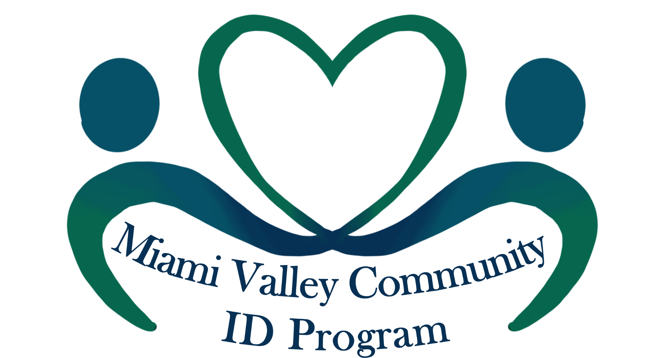
Do You Need A Valid Photo ID?
The Community ID is for ANY resident who may have limited access to government issued forms of identification, and for those who support a diverse and inclusive community.
It is not a government issued form of ID or a driver’s license, but it is a verifiable form of identification that says you are a part of our community. It can be used as a tool by law enforcement, city agencies, health centers, schools, and businesses to better identify, serve, and protect you.
DATE: Saturday, February 19 & Saturday, March 5, 2022
TIME: 9:00 am – 12:00 pm. Doors open at 9:00 am. Mandatory orientation at 10:00 am.

LOCATION: Fellowship Hall of Westminster Presbyterian Church
125 N. Wilkinson St. Dayton, OH 45402

REGISTRATION: Call (937) 333-1813 by February 15 to register for either date.

Limit: 60 participants per date

REQUIRED ITEMS YOU MUST BRING WITH YOU:
- Photo ID (expired driver’s license, national ID card, matricula consular or other embassy ID, passport)
- Proof of residency (utility bill, rent agreement, medical record, bank statement)
- $5.00 cash
THE PROCESS:
- Once doors open you will receive a number and other necessary documents.
- Listen to the mandatory orientation about the benefits and limitations of the ID card, then engage in valuable dialogue with law enforcement and other community partners.
- We will review your required documents, record your information into our ID database and take your picture.
- We will double check, print, and send your ID to your current address within 1-2 weeks.
- For more information, email MiamiValleyCommunityID@gmail.com

